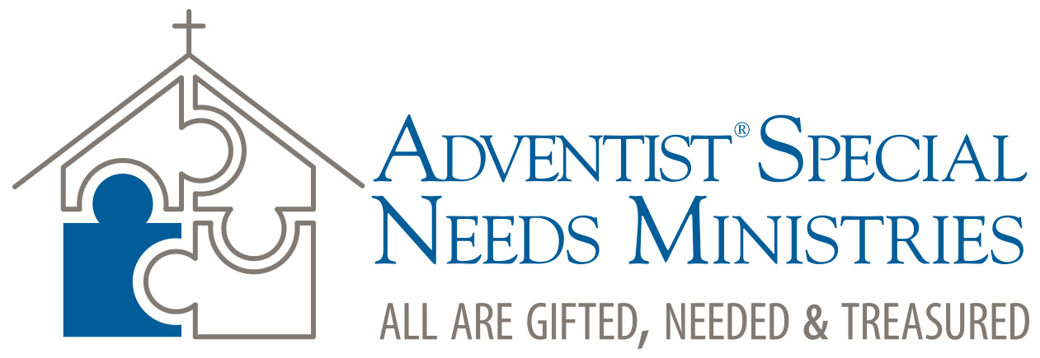

1. Introduction to Special Needs Awareness Day, Sabbath School
  - This material has been prepared by Lee Dunstan, editor of the South Pacific Division Signs of the Times, who also cares for that Division’s special needs work as Manager of its Christian Services for the Blind and Vision Impaired ministry.

  - Theme: All are gifted, all are needed, all are treasured

  - Aim: To create (1) Awareness of those with special needs (2) to promote a meaningful Acceptance of those with special needs, and (3) prompt to Action or practical help for those with special needs.

  - Be mindful in presenting (and in our relationships with) those with disability that we all, as a result of sin, are broken in some way. Acknowledge that we all have a “disability problem.” It is a matter of degree. We all are broken and are in need of wholeness. Only at home in heaven, when, having been changed in moment from mortal to immortal, will we become whole.

  - While Special Needs Ministries Emphasis Day should focus on the specific areas of blind, deaf, mental and physical disability, and the orphans, giving emphasis those impairments is reminder of what they cannot do. So please emphasize the positive—what they can do and what they can and do contribute. Involving those with disability in any of these forms—showing rather than telling—is the key here. They come with unique possibilities and gifts to share with others of which those “others” may be oblivious.
  - Note: Sabbath School generally consists of introductions, prayer, special music and congregational singing, presenter/leader remarks, mission, offering and Bible study. This model aims to fit this general format, but should be adapted to local and personal situations. The kit provides source material and ideas for each of these areas to use or adapt to a local context.

  - Kit contents:
  - Introduction to SNM program
  - Biblical relevance
  - Facts and stats
  - Quotations
  - Inspiring Personalities with disabilities
  - Special music (for children’s participation)
  - Special Needs prayer (not done yet)
  - Discussion points (for practical implementation)
  - General Special Needs Ministry information

  - Adapt as you see fit and as resources and personnel are available. This is not prescriptive.

  - Suggestions:
  - Choose a hymn by Fanny Crosby (see notes on her life), who was blind all her life.
  - Offering special music: https://www.youtube.com/watch?v=wu3b4RPwQPw

