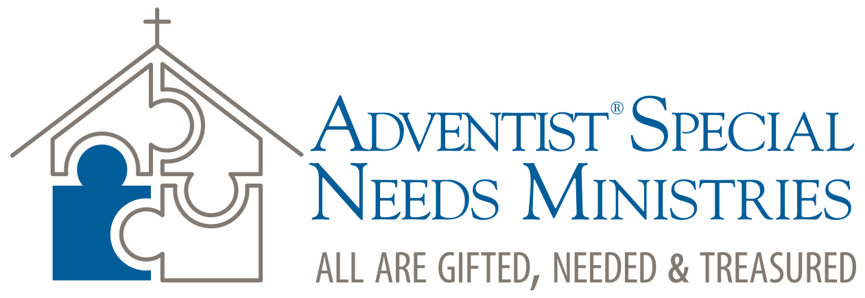

Special Needs Day Church Sermon  
Sabbath 22 April 2017

Prepared by Patrick Johnson ([pjohnson@ted-adventist.org](mailto:pjohnson@ted-adventist.org)), Trans European Division

“Three Words”

# Key text: Luke 18:35–43

# Introduction

There is a road-safety nursery rhyme that I remember from my childhood:

“Stop, look, and listen, before you cross the street.

First use your eyes and ears, then use your feet.”

I must admit that all these years later I could only remember the first two lines, so I had to look up the rest of it on the internet.

For today’s sermon we’re not going to learn a nursery rhyme but using words: stop, listen, and learn. The passage we will focus on illustrates how these three words are needed in order to develop balanced and healthy churches. These are churches that include people with disabilities in their ministries, in their decision-making processes, and in the everyday running of their churches.

# 1) Stop (verse 35)

According to Mark 10:46 this man’s name was Bartimaeus. Here in Luke 18:35 he is described as poor, begging, and sitting in the dust. Bartimaeus belonged to that 5 to 10 per cent of the population known as “expendables,” for whom society as a whole had no need. He was a stereotypical beggar. He had a disability, which meant that was unable to work, which resulted in him being poor, and so he ended up begging. Bartimaeus, the expendable.

Seeing him sitting there by the roadside would have evoked feelings of embarrassment for the few moments it took to walk past him. We all know what it’s like to walk past someone who is begging. We often avoid eye contact because then it makes it easier to ignore their pleas for help. Interestingly, the parable that Jesus tells in Luke 16:1–13 gives us an insight into the general attitude towards begging. There in verse 3 Jesus quotes the shrewd manager as saying that he’s not strong enough to dig and he’s too ashamed to beg. Make no mistake about it, begging was generally seen as embarrassing and degrading. But Bartimaeus’ need overruled his pride. He most likely sat at the most strategic place outside the entrance to the town of Jericho in order to get as much money as possible. Bartimaeus the expendable. A drain on resources.

Today we don’t use the label “expendables” but we do have other stereotypical ways of labelling people. We use terms that stereotype according to skin colour, body size, ethnic background, gender, and ability. The term ‘Disability,’ for example, often carries with it the idea of something negative, something a person cannot do, something lacking, and is treated as a problem of the individual.

We can imagine the effects of stereotyping on Bartimaeus. He could easily have sat by the roadside with an overwhelming sense of hopelessness at the prospect of never being able to be cured. He no doubt experienced periods of dark depression especially at the thought of being condemned to a life of a beggar. Being cut off from normal social relations would also have led to feelings of real loneliness.

In 2015 some research interviews were done with people with physical disabilities in the SDA church in Europe. During these interviews the participants described that they experience similar feelings when they meet stereotypical attitudes from church members. One lady, who is blind said, “Coping with the disability is easy compared to how people treat you sometimes. I often wonder if they think that you don’t have feelings like other human beings.”

One of the main problems with stereotyping is that it makes us insensitive to the individual. As one theologian has said, “People look alike only when you cannot be bothered to look at them closely.” Stereotyping hinders us from looking closely at individuals. Have you taken the time to ‘look at’ or engage personally with a person with disabilities? You probably realised that you began to notice the person and forget about the disability after a while.

This is the first lesson we learn from Bartimaeus: stop stereotyping. If we are to create churches that are welcoming to all people, we need to make a conscious effort to resist the natural tendency to stereotype people who live with impairments.

# 2) Listen (verses 38–41a)

Crowds are noisy gatherings, especially moving crowds. We can imagine that all the different conversations that were going on at the same time in the crowd following Jesus would have produced quite a noisy environment. There would have been people calling out for his attention from every direction. Yet when this man starts calling out for Jesus he was rebuked and told to be quiet. He was hindered from having a voice. It’s as if they didn’t want his voice to be heard. Why? Why shouldn’t he be heard? Why was his voice rebuked?

This story is another evidence of the authenticity of the Bible because it so accurately portrays human experience. Bartimaeus’ struggle to have his voice heard is typical of so many people today who live with disabilities. One of the most disabling activities that is done to people with disabilities is to have others talk about them but not listen to them. Deborah Creamer, a theologian who lives with a physical disability, puts it very pointedly, ‘The community of faith has failed to honestly engage with people who have disabilities, to seek out and listen to their stories, and instead tends to only speak to or about them or does things for them.’ (Deborah Creamer, ‘Toward a Theology That Includes the Human Experience of Disability’, *Journal of Religion, Disability & Health*, 7 (2003), p. 60.)

In today’s world we may not actively tell people with disabilities to be quiet, but we can be in danger of ignoring their voice. One of the goals of today’s Disability Awareness Sabbath is to give a voice to this often-neglected group. Some may be like Bartimaeus, who shout even louder when they’re resisted or ignored. But others, who are less bold, can easily be ignored for years in a church. Let’s not merely listen once per year, but make it a habit to listen regularly to all members of our church.

As disciples our aim is to be like Jesus. Jesus’ question to Bartimaeus in verse 41 is really quite striking. “What do you want me to do for you?” You would think that it’s obvious what a blind man wants. But if you take the time to listen to the stories of disabled people, you will hear them describe numerous instances where people have assumed they know what the disabled person wants. One young man, who is wheelchair dependent, described how he was once sitting at the side of a road, minding his own business and deep in his own thoughts, when someone came up behind him and pushed him across the road, assuming that he was waiting to be helped across!

Jesus didn’t assume anything with Bartimaeus. He gave him a voice. He treated him with the respect he deserved as a human being and listened to him articulate his need. This is the second lesson from Bartimaeus’ story: listen. It’s an encouragement for us to be more like Jesus who listened to him, rather than the crowd who attempted to silence his voice. Today is a perfect opportunity for us to give a voice to our disabled members and listen to their stories.

# 3) Learn (verses 36–38, 43)

Notice how Jesus was described in verse 37, “Jesus of Nazareth.” He was spoken of in terms of his geography. Some people in the crowd only viewed him as a man from Nazareth. That’s the natural and obvious way to describe someone. Verse 38, on the other hand, shows that Bartimaeus seemed to have a more spiritual view of life. He called Jesus, ‘Son of David.’ This is a Messianic term. It points to his recognition of Jesus as the Promised One, as he is introduced in Matthew 1:1.

How did he know that Jesus was the “Son of David”? He must have heard stories of what Jesus had done, that seemed to correspond with descriptions of how the Messiah was expected to behave. Thus, the flame of faith and hope was kindled in his heart that if he could meet this man he too could be healed! His faith allowed him to see more than what meets the eye.

There is much we can learn from people with disabilities. We can learn how to have a faith outlook on life. One of the things that will often impress you when speaking with disabled people is how reflective their faith tends to be. One lady said she feels that having her disability has drawn her closer to God than perhaps would have been the case if she didn’t have a disability, because it has made her more reliant on God. That’s an important lesson for us all to learn. That no matter our abilities, we are all dependent on God.

Perhaps the way we can learn most from people with disabilities is to allow them to take ministry and leadership positions in the church. In verse 43 we are told that Bartimaeus, “followed Jesus, praising God. When all the people saw it, they also praised God.” He seemed to turn the tone of the crowd into a mood of praise! All too often people with disabilities are seen as liabilities, a drain on resources, and mere receivers of charity, rather than as people with valuable resources to offer their local community.

If we truly believe in the priesthood of all believers, one way we can show it is by exhibiting an attitude of inclusivity towards disabled members. One blind member described how he had been a member of his church for many years merely attending each Sabbath. Then about four years ago he was pleasantly surprised to be asked to serve as a deacon! He now refers to life in church as brilliant, exciting and fulfilling. Why? Because he has the opportunity to offer his abilities to the church.

Bartimaeus had his eyes cured by Jesus, but it would perhaps be correct to say that the real healing came about as a result of him being accepted into the community. He was healed when the community followed his lead in praising God. This should teach us that even if people are not cured of their impairments, our churches can still be places of healing by including people in fellowship and allowing them to flourish by using their God-given gifts and talents.

The third lesson from Bartimaeus is learn. We are to approach people with a humble and expectant attitude that we can learn from them, that they are valuable and gifted individuals that help to make the body of Christ complete.

**Conclusion**

The strapline that accompanies the General Conference special needs logo reads: “all are gifted, needed and treasured.” For this to become a reality in our churches we should practice three words: stop, listen and learn. By consciously seeking to stop stereotyping people with disabilities, by taking the time to listen and giving them a voice, and by approaching them with an attitude to learn from them, we will be taking huge strides towards making our churches places where all are truly needed and treasured