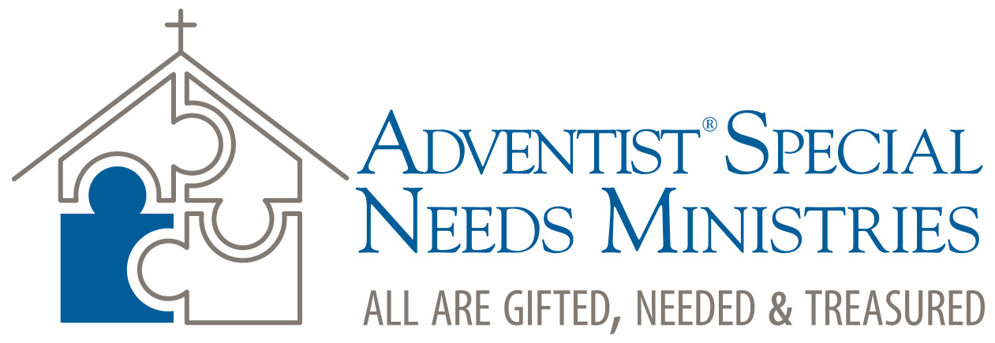

8. Special Needs Resources

Larry Evans Twitter: https://twitter.com/DrLarryEvans
SNM Website: www.SpecialNeeds.adventist.org
Hope Channel Deaf: http://www.hopechanneldeaf.org/
Christian Record Services (blind):
http://www.christianrecord.org/
https://www.facebook.com/christianrecord/

